Lab Task 02
Zain jabbar (323)
AI (lab)
Q:1
Create PEAS specifications for a delivery robot and an LLM-based student-support agent. Produce two separate PEAS specifications with all four components. For every component give at least two concrete entries where appropriate, then explain one constraint or performance trade-off. State the operational assumptions, including what tools the student-support agent can access. Put these specifications in your .docx report.
What I did
This code prints details about a delivery robot and a student support agent, including their performance goals, environments, actuators, and sensors.
It also lists assumptions about the technologies each system uses.
The code is valid Python and should run without errors.
No specific problem or error is shown in the code.
It presents the information clearly by organizing it under headings and bullet-style lines.
Code screenshot

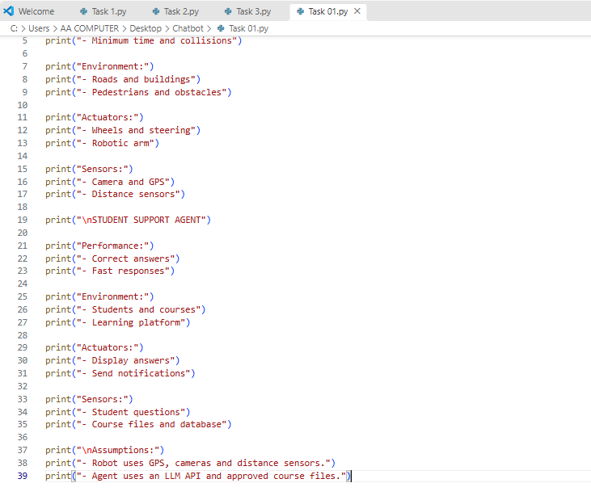
Code Explanation
This code prints information about two systems: a delivery robot and a student support agent.
For each system, it describes the performance goals, the environment, the actuators (how the system takes action), and the sensors (what information it receives).
For the delivery robot, examples include wheels, a robotic arm, cameras, GPS, and distance sensors.
For the student support agent, examples include displaying answers, sending notifications, student questions, and course files.
The final section lists assumptions about the technologies each system uses.
It only displays this information; it does not control a robot or create a working support agent.
Code Run Screenshot
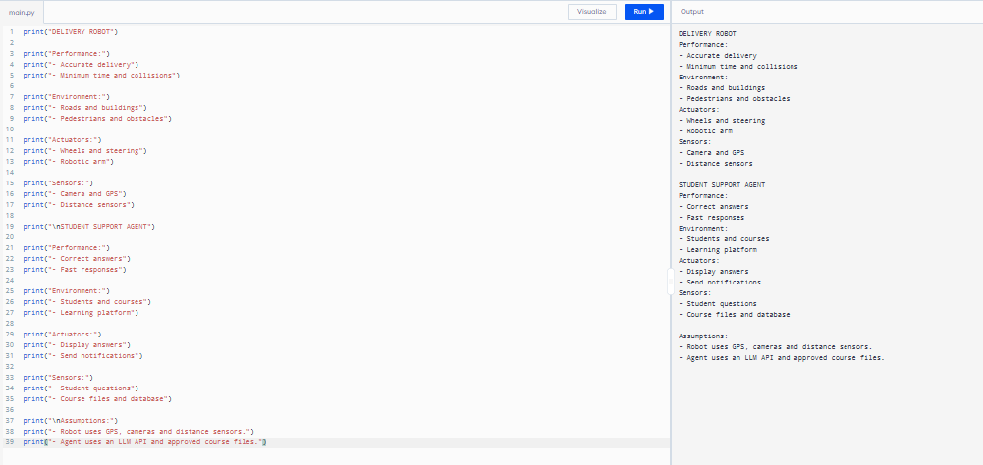
Q:2
Classify each environment as fully/partially observable and deterministic/stochastic with justification. Classify both systems from Task 1 on the two required dimensions. For each label give an example of an observable or hidden variable and an example of a predictable or uncertain action outcome. Distinguish the real environment from a simplified simulator; qualify your answer using stated assumptions.
What I did
This code stores observability and environment details for a delivery robot and a student support agent in a dictionary.
The loop displays each system’s name, observability, examples, and environment type.
It then explains when a simulator is fully observable or deterministic.
The code is valid Python, and no specific mistake or correction is shown here.
It organizes the information clearly so the two systems can be compared.

Code screenshot
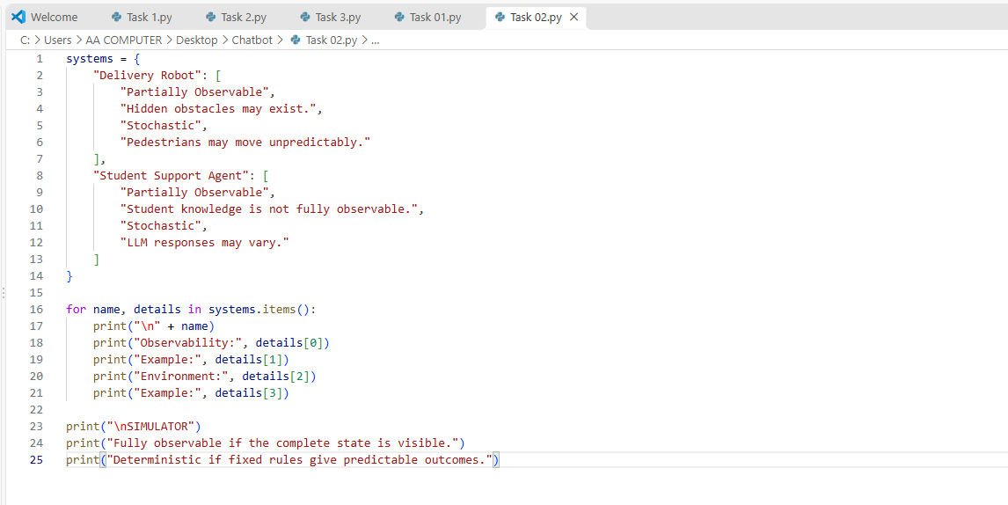
Code Explanation
This code creates a dictionary called `systems` with details about a delivery robot and a student support agent.
Each system is described as partially observable and stochastic, with an example explaining why.
The `for` loop goes through the dictionary and prints each system’s details under clear labels.
The final lines describe when a simulator is fully observable or deterministic.
In short, the program displays and compares the two systems’ environment properties.

Code Run Screenshot
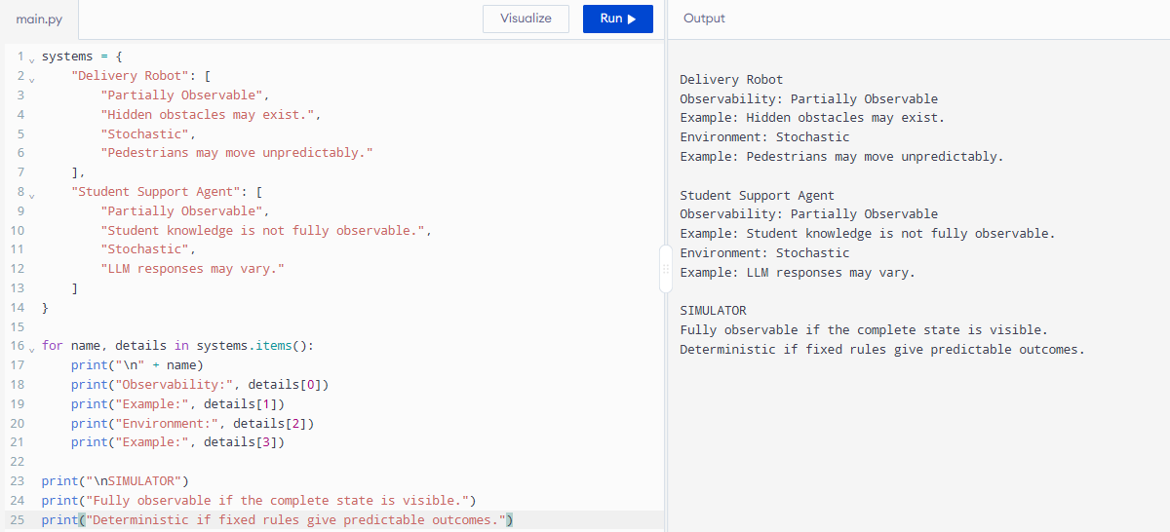
Q:3
Extend the code to remember the previous mode and avoid repeating identical control commands. Keep the existing temperature thresholds and occupancy priority. Add internal storage for the previous target mode, returning both the target and whether a command should be sent. Run repeated percepts, both exact boundaries, a mode transition and an empty-room case. Record previous mode, percept, target and command/no-command outcome.
What I did
This code simulates a thermostat that controls heating and cooling based on temperature and room occupancy.
If the room is empty, the target is `OFF`; if occupied, it selects `HEAT` below 18, `COOL` above 26, or `OFF` between those limits.
It compares the target with the previous state and outputs `NO COMMAND` when no change is needed.
The loop runs through the test temperatures and occupancy values, printing the previous state, input, target, and command.
The code shown has no obvious Python error; I can’t tell what earlier errors you fixed unless you share the earlier version or error message.
Code screenshot
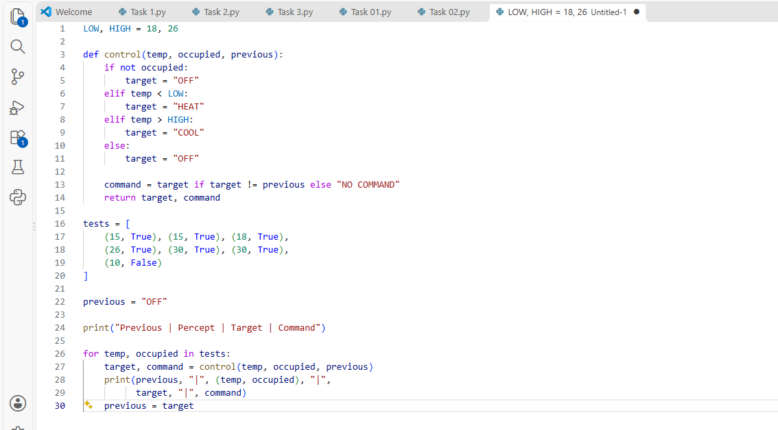
Code Explanation
This code simulates a temperature-control system with a low limit of 18 and a high limit of 26.
The `control` function turns the system OFF when the room is empty, chooses HEAT below 18, and COOL above 26.
When the temperature is between 18 and 26, it sets the target to OFF.
It compares the new target with the previous state and returns `NO COMMAND` if no change is needed.
The loop tests several temperature and occupancy readings, prints the results, and updates `previous` after each test.
Code Run Screenshot
